|  |  |  |  |
| --- | --- | --- | --- |
| **SPMI** | **FORMULIR PROSEDUR AKADEMIK** | **No** | **0531/PL4.6.2/PK/2021** |
| **BAHAN RAPAT TINJAUAN MANAJEMEN** | **Revisi** | **1** |
| **Tanggal** | **7 Januari 2022** |
| **Halaman** | **1/1** |

**BAHAN RAPAT TINJAUAN MANAJEMEN**

|  |  |  |  |  |  |  |  |
| --- | --- | --- | --- | --- | --- | --- | --- |
| No | Jadwal TM | Unit Kerja | Auditor | Auditee | Laporan Temuan | Hasil Pemeriksaan | Status |
| 1 | 11 March 2022 | Bagian Umum dan Keuangan (BUK) | Auditor 1 | Auditee BUK | Temuan 2 | Sesuai | Closed |
| 2 | 11 March 2022 | Bagian Umum dan Keuangan (BUK) | Auditor 1 | Auditee BUK | Temuan 1 | Tidak Sesuai | Closed |
| 3 | 11 March 2022 | Bagian Umum dan Keuangan (BUK) | Auditor 1 | Auditee BUK | Temuan 3 | Tidak Sesuai | Closed |
| 4 | 11 March 2022 | Bagian Umum dan Keuangan (BUK) | Auditor 1 | Auditee BUK | Temuan 4 | Tidak Sesuai | Closed |
| 5 | 11 March 2022 | Bagian Umum dan Keuangan (BUK) | Auditor 1 | Auditee BUK | tes13 | Tidak Sesuai | Closed |
| 6 | 11 March 2022 | Bagian Umum dan Keuangan (BUK) | Auditor 1 | Auditee BUK | tes123 | Tidak Sesuai | Closed |

Semarang, 28 Maret 2022

Kepala PPMP

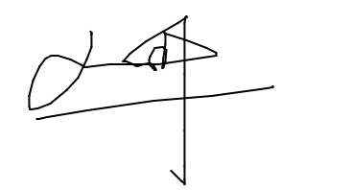

Pimpinan PPMP